**AWS INSTANCE CREATION AND CONNECT USING MOBAXTERM SOFTWARE**

1. Go to: <https://aws.amazon.com/console/> => click on login

2. Choose Region based on your location. Ex: For India: (Mumbai) ap-south-1

3. Click on launch Instance and choose Launch Instance

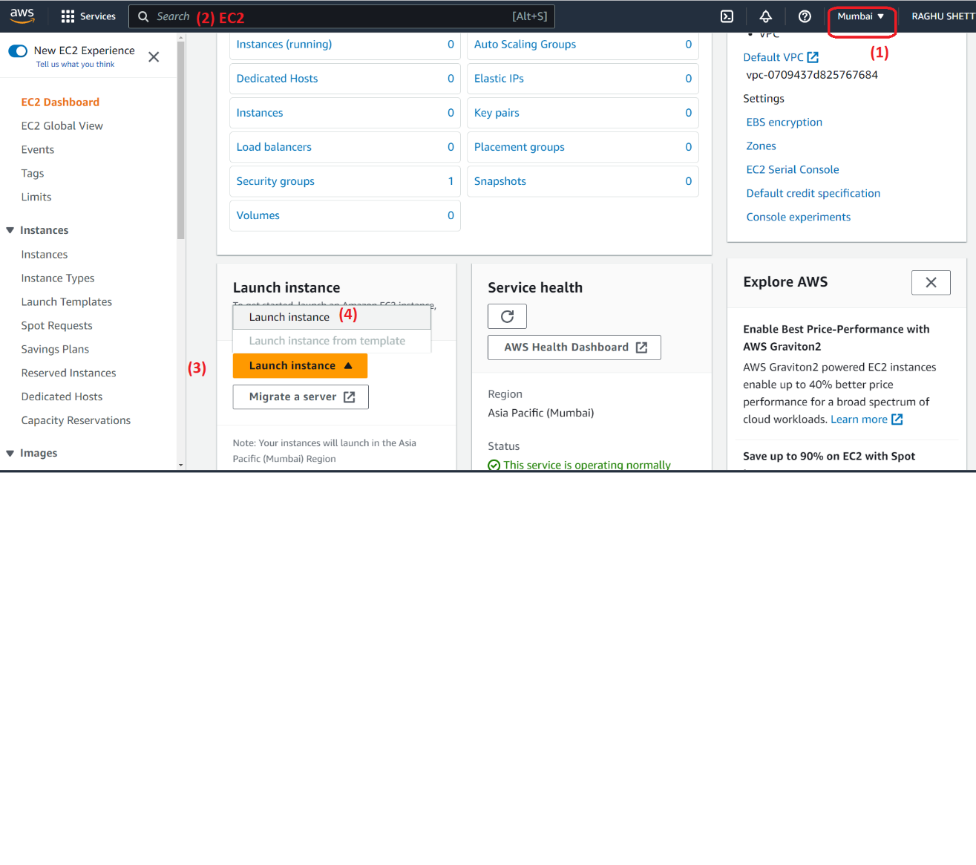

4. Enter any name for easy identity and choose Amazon Linux (AMI)

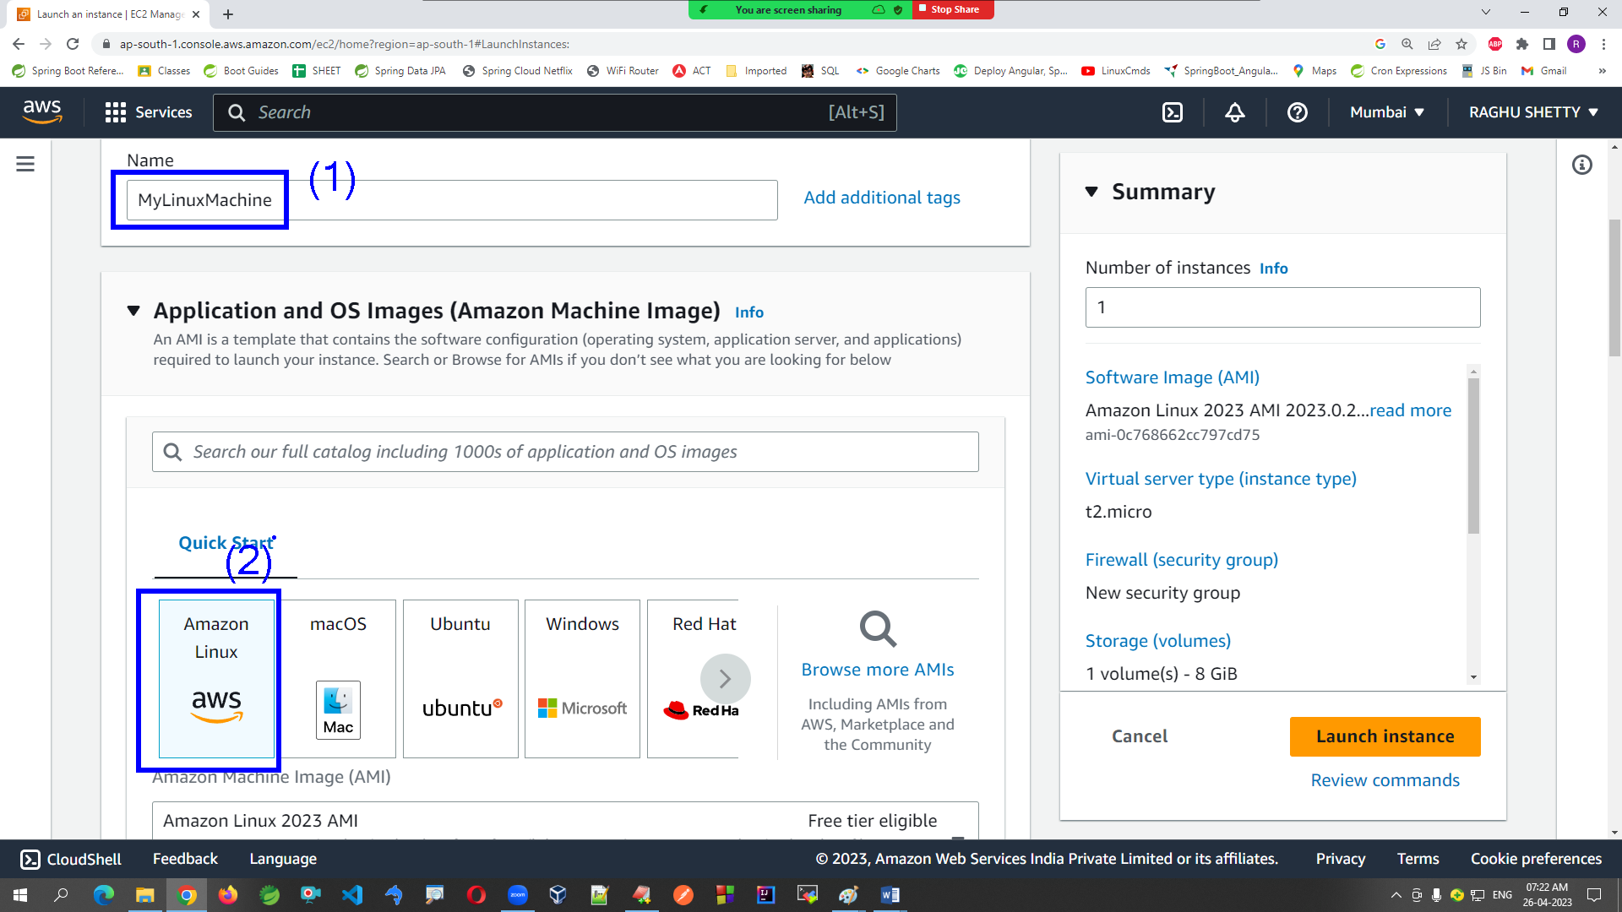

5. Please select “Free tier eligible” to avoid billing issue.

6. Click on create new Key new pair for creating a .PEM file (Privacy Enhanced Mail / Secret Key)

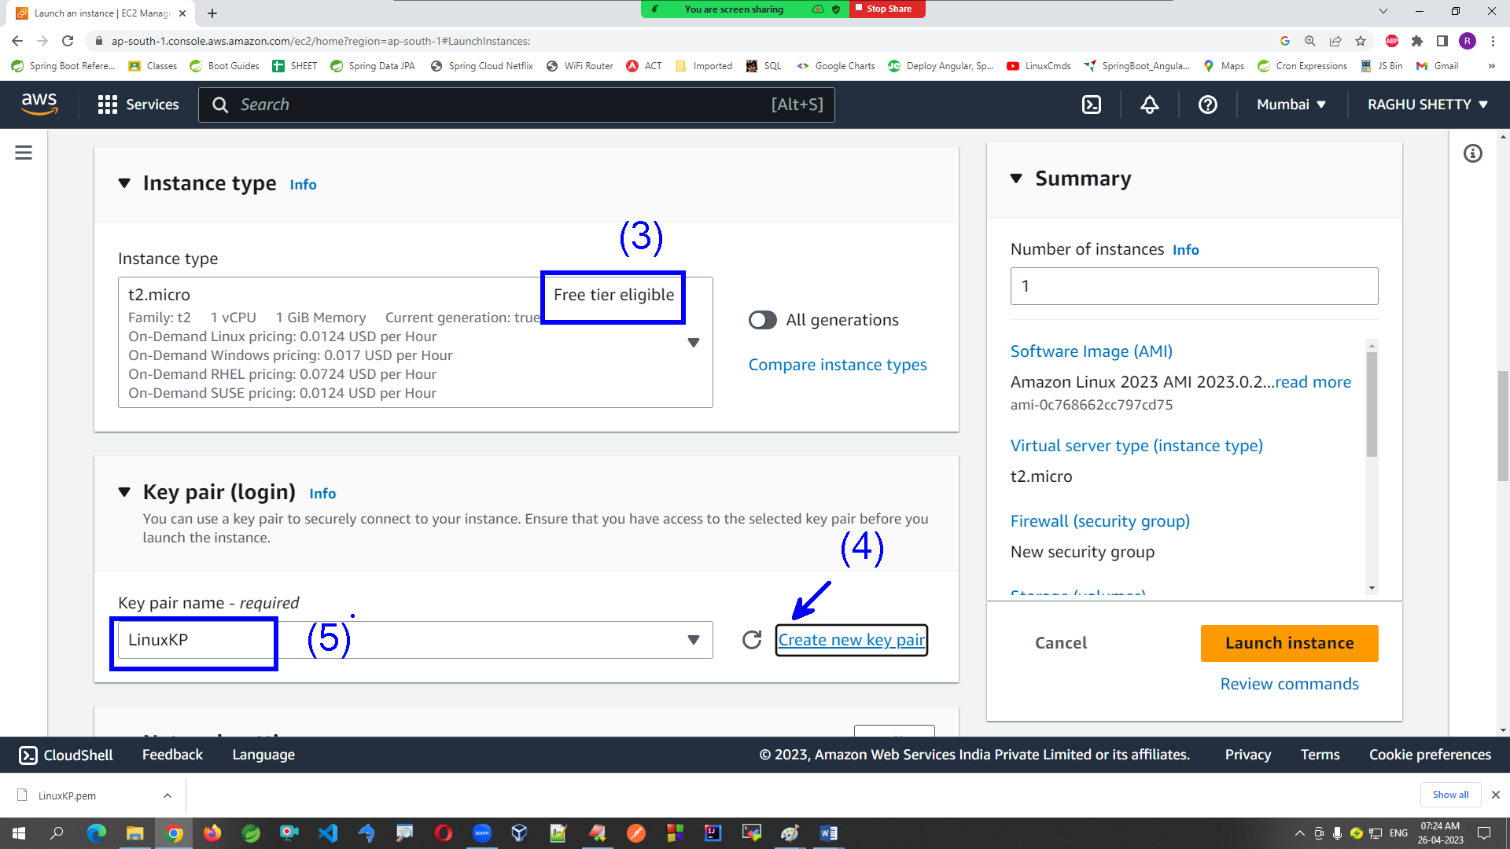

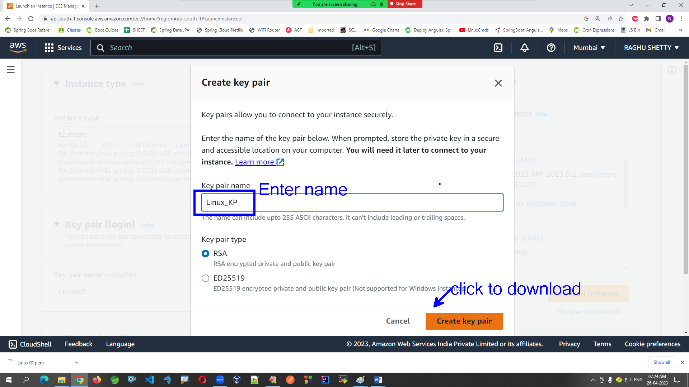

7. Keep networking details as defaults/same as selected options

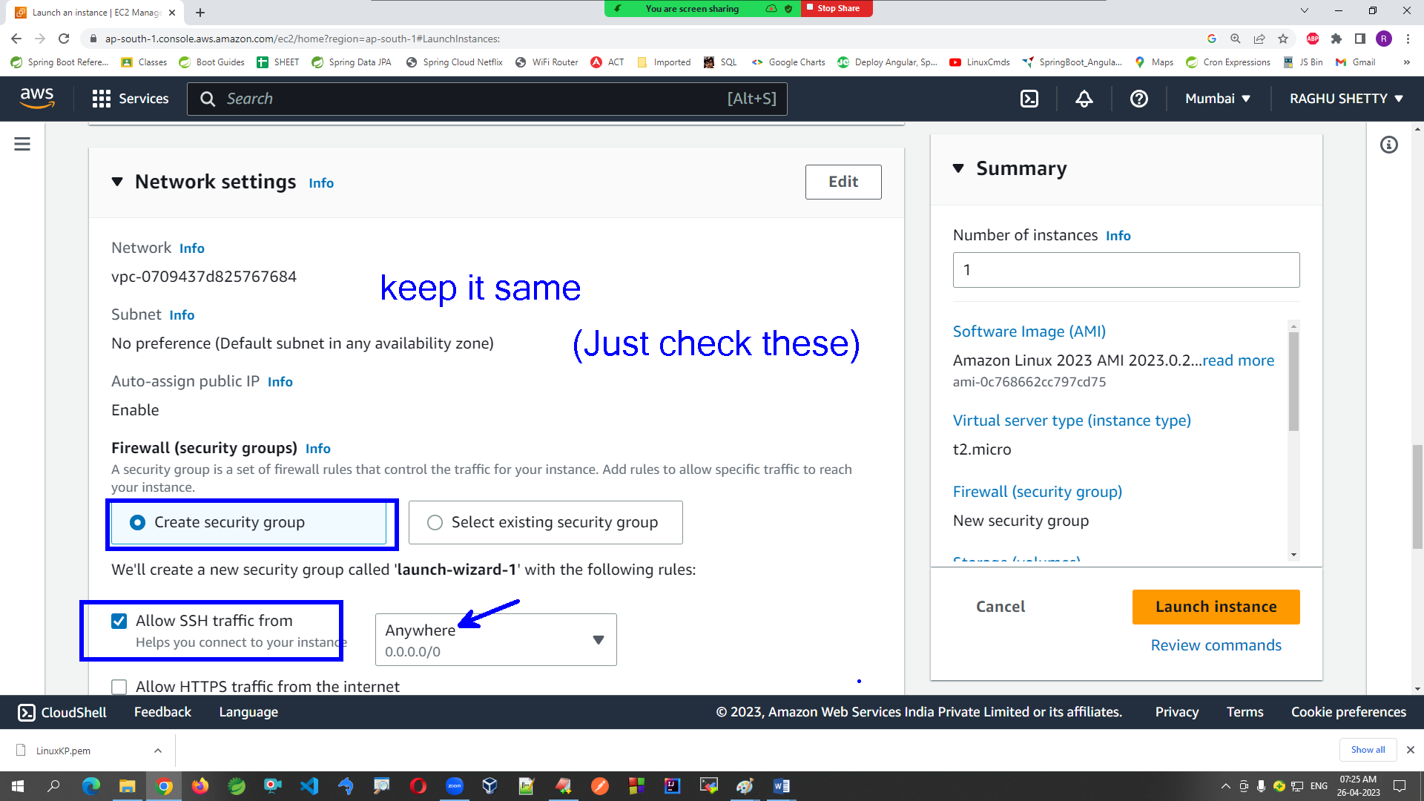

8. Keep Configure storage details as defaults

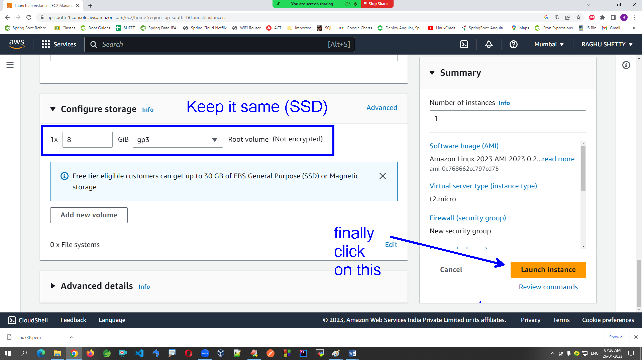

9. Wait for few seconds to get EC2 Instance created then click on ID (Showing on success page)

10. Refresh to see Instance state updated (Should be in Running)

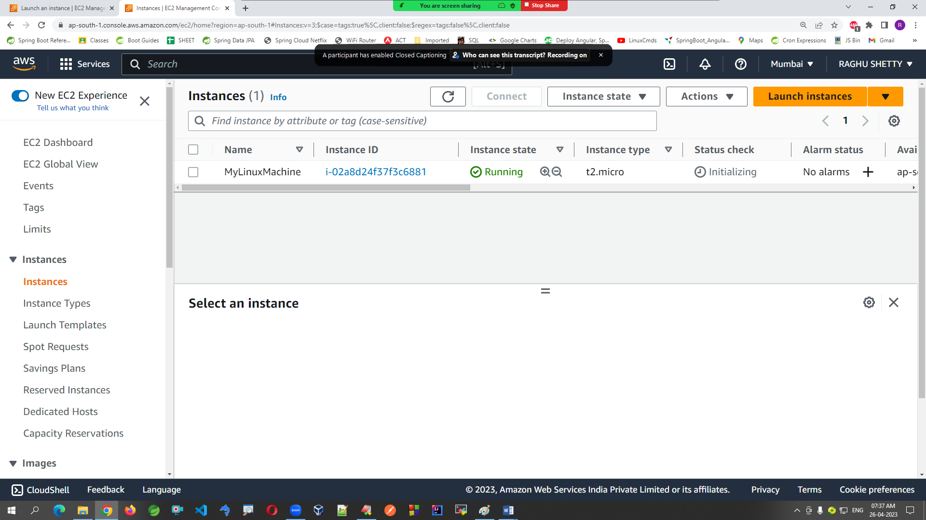

11. Choose checkbox of our instance and copy Public IP

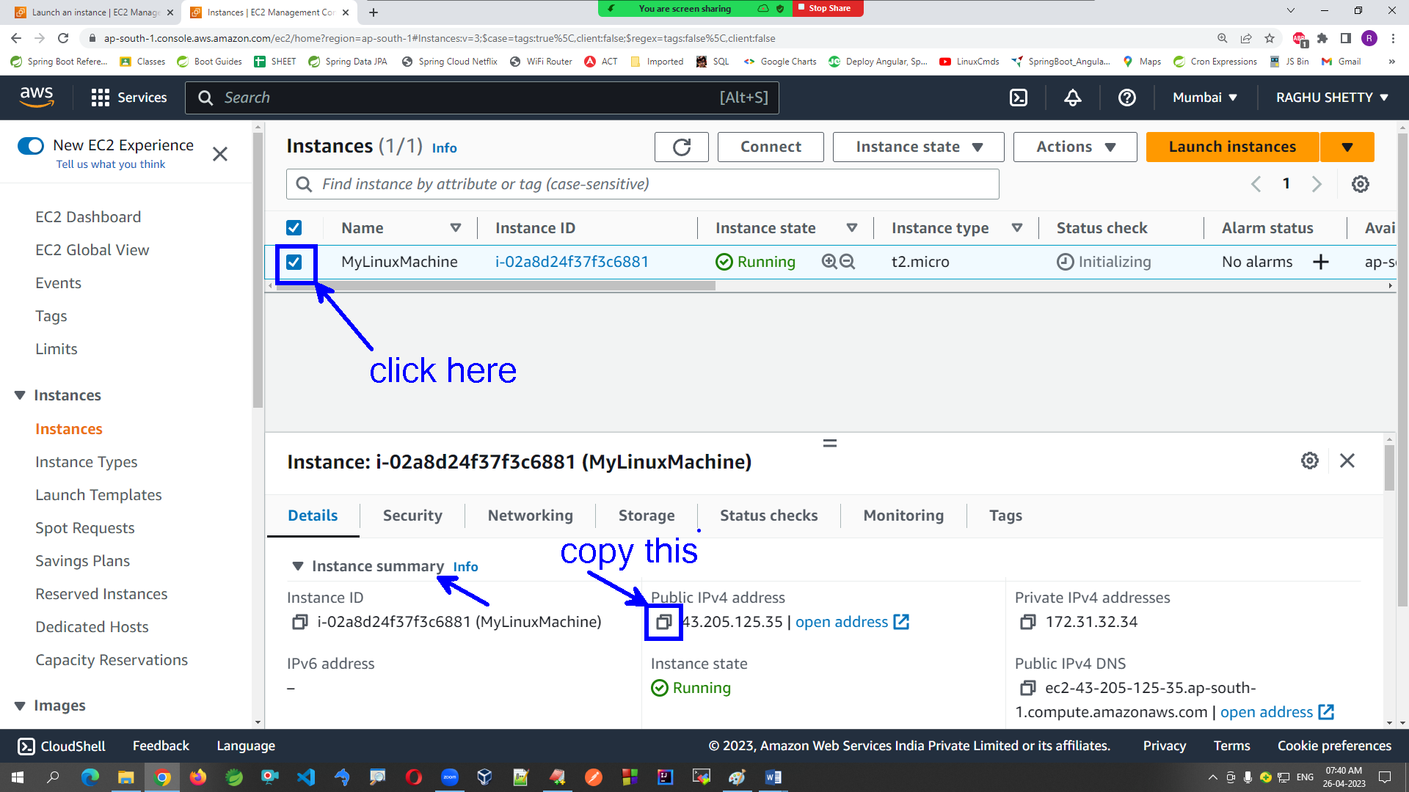

12. Open MobaXTerm and click on Session option

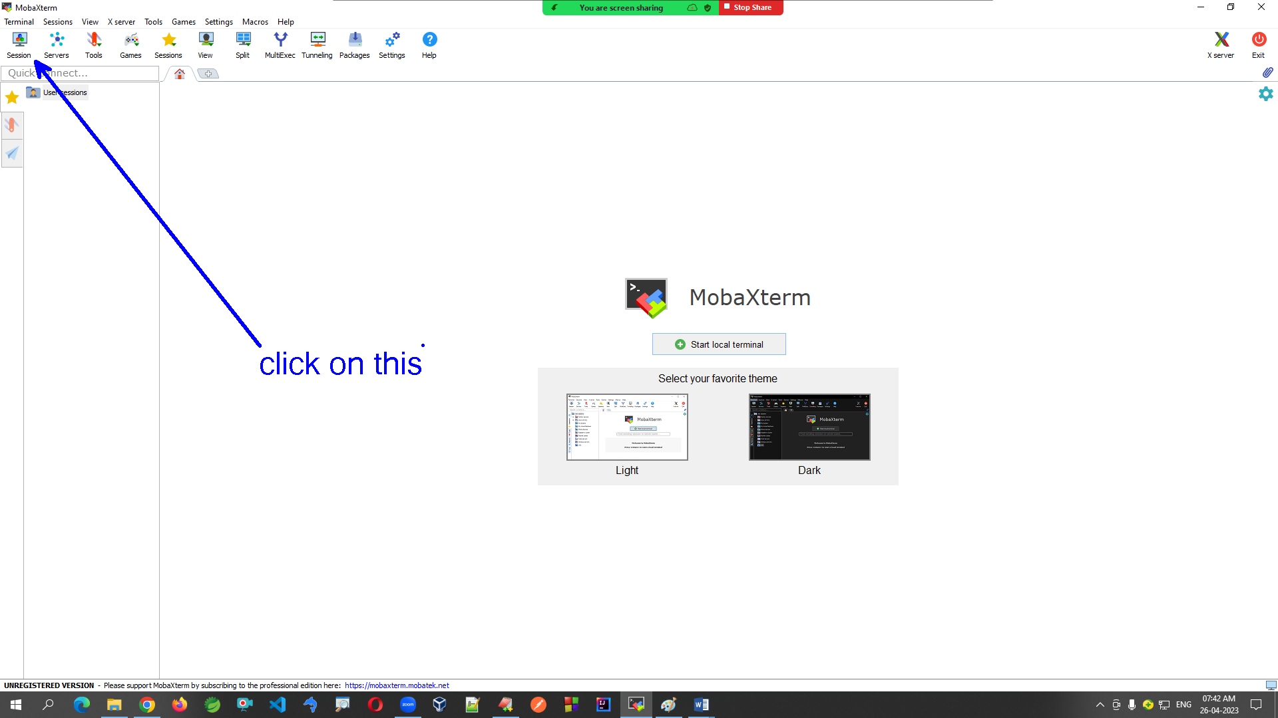

13. Select SSH and fill details also select .PEM file

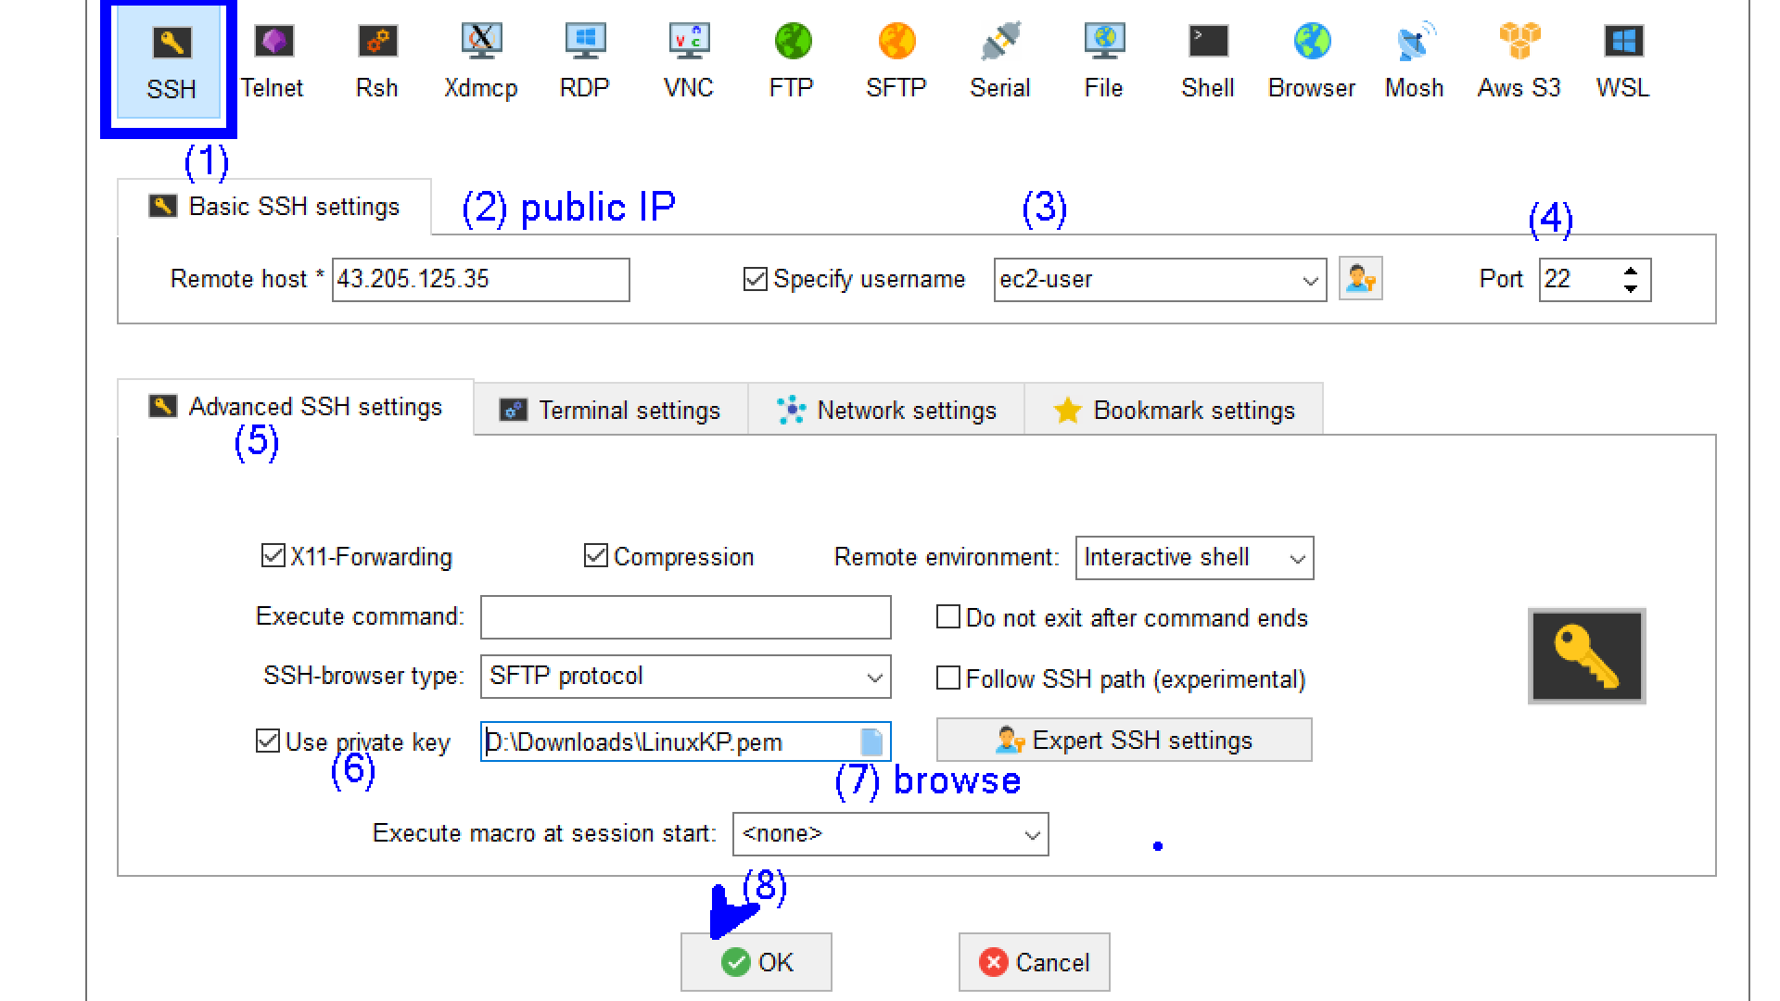

14. Type commands on terminal (ls, clear, pwd, who, date, logout)

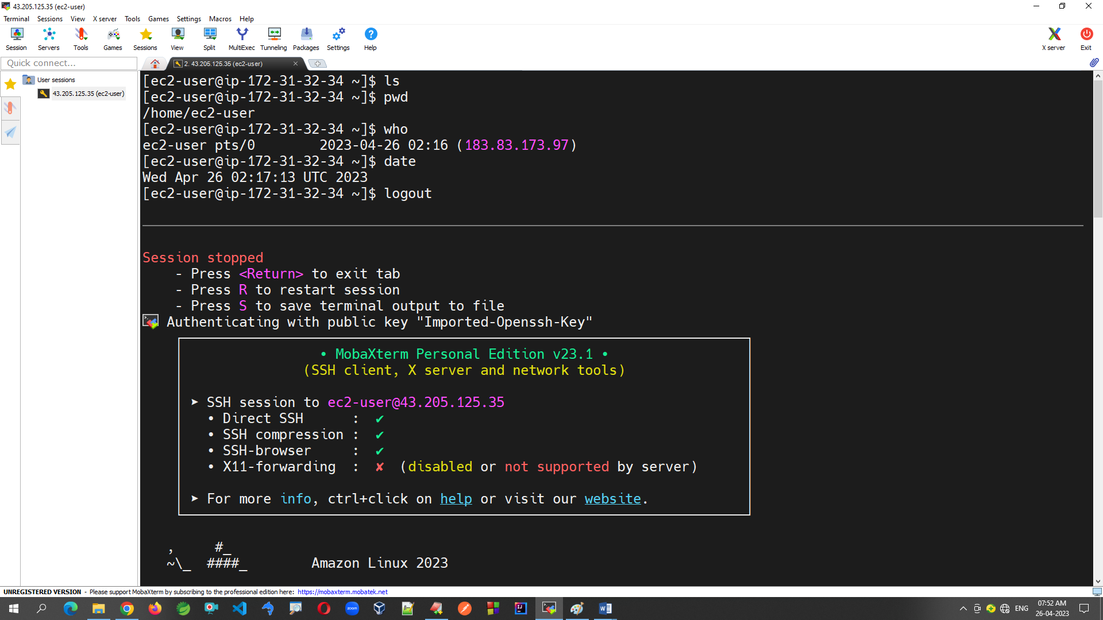

15. **Delete EC2 Instance using Instance State -> Terminate**

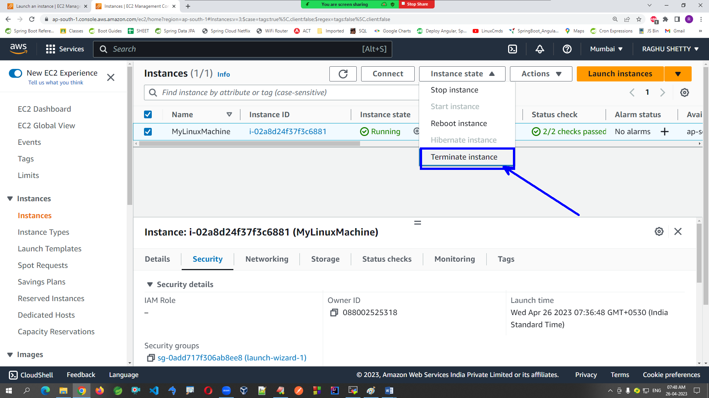

Note: bill is generated for your usage only